**Real Time Speed Control of Three Phase Induction Motor by Using Labview with Fuzzy logic**

Santhiya K, Pg Scholar,

Department of Electrical Engineering

Vivekanandha College of Engineering for Women,

Elayampalayam, Tiruchengode-637205, India

[santhiyakrishnamoorthy2@gmail.com](mailto:santhiyakrishnamoorthy2@gmail.com)

Santhosh kumar D, Assistant Professor,

Department of Electrical Engineering

Vivekanandha College of Engineering for Women,

Elayampalayam, Tiruchengode-637205, India

Santhoshkumar86@gmail.com

Devimuppudathi M, Pg Scholar,

Department of Electrical Engineering

Vivekanandha College of Engineering for Women,

Elayampalayam, Tiruchengode-637205, India

[devimurugiah22@gmail.com](mailto:devimurugiah22@gmail.com)

Johny Renold A, Assistant Professor,

Department of Electrical Engineering

Vivekanandha College of Engineering for Women,

Elayampalayam, Tiruchengode-637205, India

jorenoeee@gmail.com

*Abstract*— **This paper is concerned with real time speed control of three phase induction motor and implementation of voltage/frequency (V/F) speed control method with the help of Lab view. In today’s world the industrial applications can be done by using remote control. Lab view is one of the useful software which is used for monitoring and controlling the systems in industries. The induction drive system fed with inverter which is having different types of controllers, can be used to perform different actions like speed control, forward and reverse directions of the motor and along with that motor can be stopped. These things can be done by using the LABVIEW programming. It is a human machine interface (HMI) design software which is user friendly and we can easily interface hardware. In this method we use self-tuning fuzzy logic controller and variable frequency drive. The result was implemented in lab view software. It is provide better performance Because of its simplicity, the V/F control also called as the scalar control, is the most widely used speed control method in the industrial applications. The proposed technique gives better performance for three phase induction motor than the conventional technique. The main advantage of the proposed system is quick settling time, intelligent technique. Both Resistive and Inductive loads are implemented in power system, but maximum amount is given out by Inductive load. So in this paper we used to control the induction motor speed in real time.**

**Keywords—**Fuzzy logic, Induction motor, Microcontroller, Labview, Variable frequency drive (VFD).

1. **Introduction:**

Electrical Energy has the contribution more than 40 % of all energy sources usage on Earth. In the upcoming years the percentage contribution of Electrical Energy will be increase. More utilization of Electrical Energy is to convert the Electrical Energy into Mechanical Energy via different kinds of electric motors like DC Motors, Induction Motors and Synchronous Motors. From the economic point of view Induction Motor are cheap compared to DC and Synchronous Motors. Induction Motors are most popular and widely used drives in industries as well as for domestic applications. It is very important to control the speed of induction motors in industrial and domestic applications. Induction motors can be broadly classified into two types based on their speed control techniques – scalar control and vector control. By using scalar control method we can control the magnitude of voltage or frequency of the induction motor [10].In the present time, in the most of the applications, AC machines are preferable over DC machines suitable to their simple and most robust construction without any mechanical commutators. Induction motors are the most widely used motors for appliances like Industrial control, and automation; hence, they are often called the workhorse of the motion industry [1]. Control of voltage, frequency and current is required in variable speed applications for ac machines drives. Speed of induction motor can be determined with the help of frequency of supply system.

1. V\F Speed Control Method of Three Phase Induction Motor

The torque developed by the induction motor is directly proportional to the magnetic field, which is produced by the stator. The stator voltage is directly proportional to the product of stator flux and angular velocity. This makes the flux produced by the stator proportional to the ratio of applied frequency and voltage of supply. The voltage and frequency varied by the same ratio, the torque can be kept constant throughout the speed range. This makes constant ratio of voltage and frequency is the most common speed control of an induction motor. The torque developed by the induction motor is directly proportional to the ratio of voltage and frequency. By varying the voltage and frequency, keeping their ratio constant, then the torque produced by induction motor will remain constant for all the speed range.Fig.1 shows the torque-speed characteristics of the induction motor with V/F control. The voltage and frequency reaches the maximum value at the base speed .We can drive the induction motor beyond the base speed. The torque developed by the induction motor is directly proportional to the V/F ratio will not remain constant throughout the speed [1].



Figure 1.Torque-speed characteristics of the induction motor

Other than the variation in speed, the torque-speed characteristic of the V/F control is the following:

* The starting current is low.
* The constant operating region of the motor is increased. Instead of simply running at its base/ rated speed (NB), the motor can be run normally from 5% of the synchronous speed (NS) up to the base speed. The torque created by the motor can be kept constant throughout this region.
* Then almost constant rated torque is available over the entire operating range, the speed range of the motor becomes wider. User can set the speed as per the load requirement, thereby achieving the higher efficiency.

1. **Fuzzy logic**

The input and output variables map into the following fuzzy set:

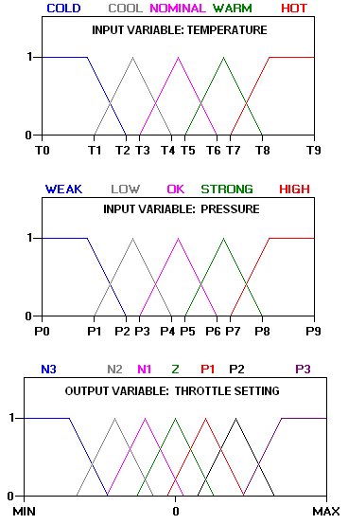

Figure 2. Input and output variables map

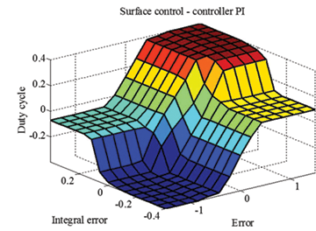

Figure 3. surface control of fuzzy logic

1. **Lab view**

The acronym for Lab VIEW is Laboratory Virtual Instrumentation Engineering Workbench. And it issued in the form of graphical representation for producing flexible and measurable designs, controlling and testing applications with less amount of cost. By using Lab VIEW one can interact with the signals of the real world in order to analyses the data for more information which is meaningful, and the result or output can be seen by using web, report and display. Irrespective of experience in programming the user can work easily and fast with lab view.

In Lab VIEW we use G programming where G indicates graphical. And it can also be called as dataflow programming because in order to execute the designed program it will depend on the block diagram structure. If we compare LABVIEW and text programming, LABVIEW is more flexible and user friendly why because here we can develop the program and can be connected with relevant blocks through wiring. The programs in LABVIEWare named as virtual instruments, or VI, due to their appearance and mode of operation of the instruments like oscilloscope and multi- meters. In LABVIEW we are having loops like for, while loops and case structure, sub blocks[3].



Figure 4. lab VIEW setup

1. **PWM (Pulse Width Modulation)**

Pulse width modulation (PWM) is a [modulation](https://en.wikipedia.org/wiki/Modulation) method used to encode a [message](https://en.wikipedia.org/wiki/Message) into a [pulsing signal](https://en.wikipedia.org/wiki/Pulse_(signal_processing)). Even though this modulation technique can be used to encode information for transmission, its main use is to allow the control of the power supplied to electrical devices, mainly to inertial loads such as motors. In addition, PWM is one of the two major algorithms used in [photovoltaic](https://en.wikipedia.org/wiki/Photovoltaic) solar battery chargers, the other being [maximum power point tracking](https://en.wikipedia.org/wiki/Maximum_power_point_tracking).

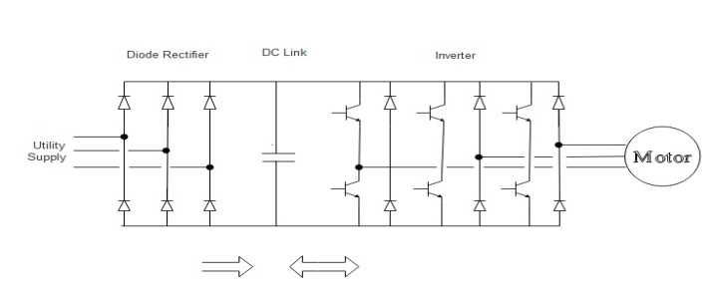

Figure 5.PWM inverter

The average value of [voltage](https://en.wikipedia.org/wiki/Volt) and current fed to the [load](https://en.wikipedia.org/wiki/Electrical_load) is controlled by turning the switch between supply and load on and off at a quick rate. The longer the switch is on compare to the off periods, the higher the total power supplied to the load.The PWM switching frequency has to be much higher than what would affect the load (the device that uses the power), which is to say that the resultant waveform perceived by the load must be as even as possible. The term [duty cycle](https://en.wikipedia.org/wiki/Duty_cycle) describe the proportion of on time to the usual interval or period of time; a low duty cycle corresponds to low power, because the power is off for most of the time. Duty cycle is expressed in percent, 100% being fully on. The major advantage of PWM is that power loss in the switching devices is very low. When a switch is off there is practically no current, and when it is on and power is being transfer to the load, there is almost no voltage drop across the switch. Power loss, being the product of voltage and current, is therefore in both cases close to zero. PWM also works well with digital controls, which, since of their on/off nature, can easily set the needed duty cycle.

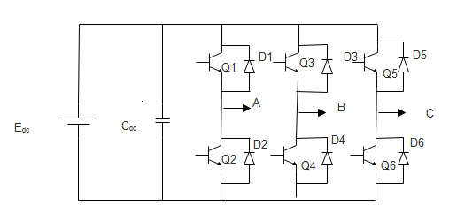The Voltage source inverter's are commonly used for [variable frequency drive](https://en.wikipedia.org/wiki/Variable-frequency_drive) applications and for high power applications, such as [HVDC](https://en.wikipedia.org/wiki/High-voltage_direct_current) power transmission. A basic three phase inverter consists of three single-phase inverter switch each connected to one of the three load terminals. For the most basic control scheme, the operation of the three switches is coordinated so that one switch operates at each 60 degree point of the fundamental output waveform. These create a line to line output waveform that has six steps.

Figure 6. Voltage source inverter(VSI)

The six step waveform has a zero voltage step between the positive and negative sections of the square-wave such that the harmonics that are multiples of three are eliminated as described above. When carrier based PWM technique are applied to six step waveforms, the basic overall shape, or envelope, of the waveform is retained so that the 3rd harmonic and its multiples are cancelled.

## **PIC18F452 Microcontroller**

## The 18F452 has 153GB of RAM and 16k of program

## Memory. It has four port namely as port a, port b, port c and

## Port d. Each port has eight pins. As shown in figure the pin

## Num RA belongs to port a and same as for RB, RC and RD.

These are the power supply pins. VSS is ground and VDD is the positive supply pin. The range of supply is 5V to 3V. The maximum supply is 5V and minimum is 3V. (above 5V the IC can damage so be care full).Since microcontroller has some kind of timing, so we connect an external clock with these pins. In normal mode this pin connects to the positive (5V) supply. Specially, this pin is used to erase the memory location. These are the bidirectional ports. That can be configured as an input and output. The number following RA0, RA1 is the bit number. These is an another clock, which operate an internal timer. There are two ways for programming, the easy and DIY way. The easy way is to buy a PIC burner, which will connect to your PC and you can program it by using software. The DIY is to build your own burner and use free software to program it. In these tutorial, first we will learn the programming of PIC and will see the simulation by using Proteus. Then we will proceed to the hardware**.**

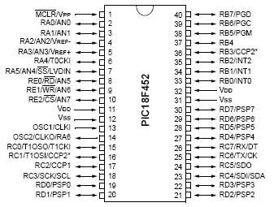

Figure 7.Pin Diagram of PIC18F452

1. **Variable Frequency Drive (VFD)**

The AC60E is a mini general purpose frequency inverter, is our independently developed electrical equipment. As a new generation of high performance v/f control drive, it is included to have modular design, small size, small temperature rise, low noise, and reliable performance**.**

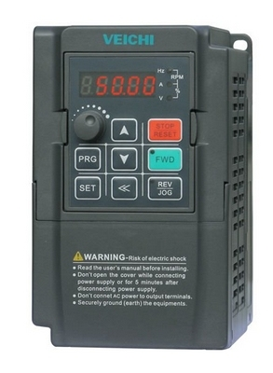

Figure 8. AC60E VFD Module

* 220V(single-phase power) 0.4-2.2kw
* 380V(three-phase power) 0.75-3.7kw

A Variable Frequency Drive (VFD) is a device that is control the voltage and frequency. That is being supplied to a motor and controls the speed of the motor. To meeting the required process demands, the system efficiency is improved. A VFD is capable of varying both the speed and torque of an induction motor. VFD's are made in a number of different low and medium voltage [AC-DC](https://en.wikipedia.org/wiki/AC/AC_converter) and DC-AC topologies.

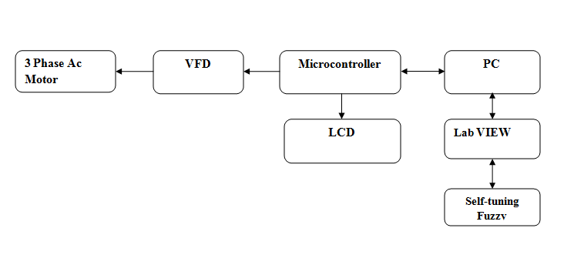

Figure 10.Block diagram of proposed system

In this proposed system, we used to control the speed of the three phase induction motor, by using v/f method. The speed of the induction motor is, set by the set pointer, and then the set speed is displayed in the LCD display. The microcontroller is employed with the Firefly coding. The VFD (Variable Frequency Drive) receive the signal from microcontroller is used to drive the 3 phase induction motor .The purpose of this VFD (Variable Frequency Drive) is used to convert the fixed voltage and frequency into variable voltage and frequency. The variable voltage is used to drive the AC motor frequently. The sensor is used to sense the speed of induction motor into microcontroller. .While using the PI controller we have some disadvantages, In order to overcome that we use firefly algorithm.

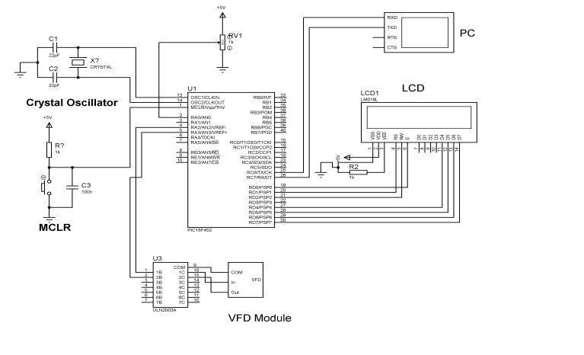

Figure 9.Circuit diagram for proposed system

The above circuit diagram is denotes the hardware implementation of speed control of three phase induction motor using variable frequency drive.

1. **Result Analysis**

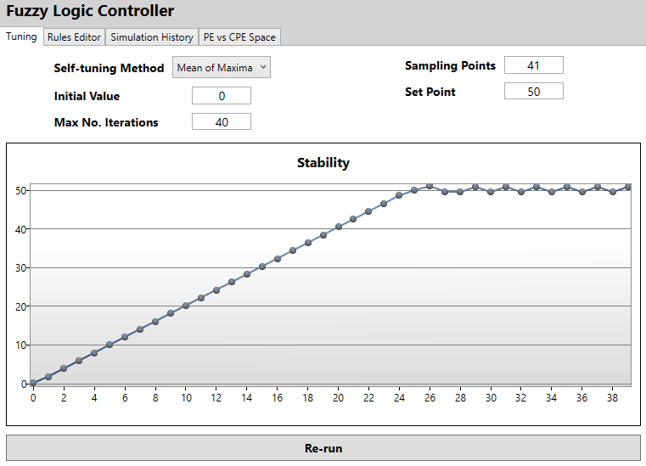

Figure 10.Stability graph for proposed system

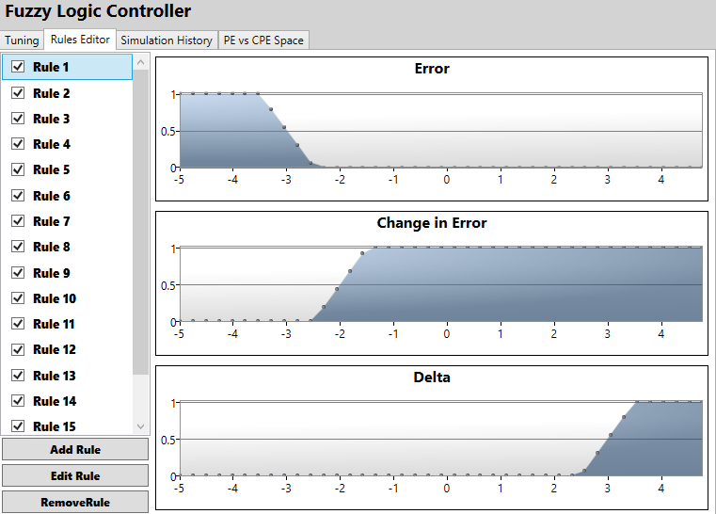

Figure 11.Error, Change in error, and Delta graph

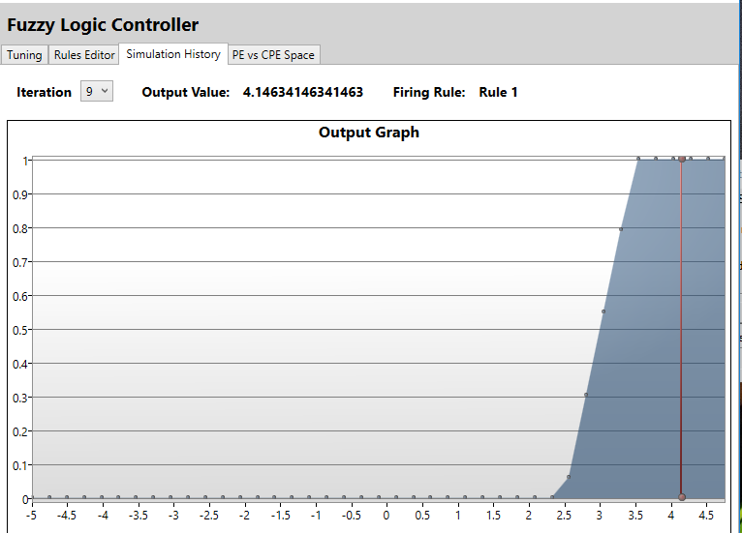

Figure 12.Output graph

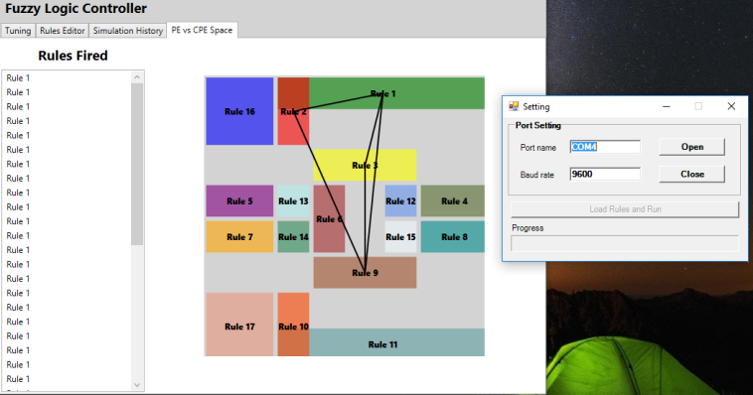

Figure 13.Rules fired for proposed system

Table 2. Comparative Study of Set speed and settling time

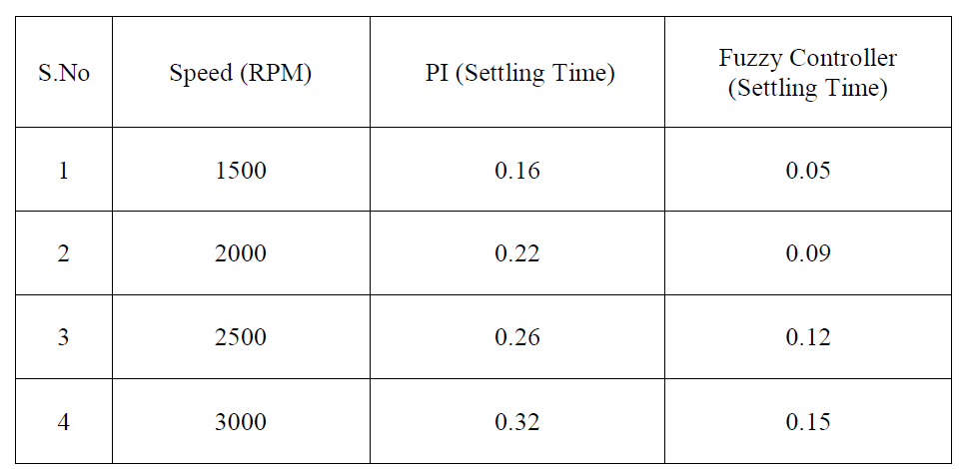

* N is the speed of rotor of induction motor,
* Ns is the synchronous speed, S is the slip.
* f= Frequency
* p= no.of.poles
* We set the speed in the set pointer in 1000 rpm

Table 2. Motor Specification

|  |  |
| --- | --- |
| Motor parameter | Specification |
| Power | 1HP |
| Type | 4-pole,squirrel cage |
| Supply | 3-phase,415V ac, 50Hz input |
| Rated current | 1.8 amp |
| Rated Speed and Torque | 1410 RPM and 5Nm |

VI. CONCLUSION

Induction motor drives are most widely used in the industrial applications. Various speed controlled methods have been developed. Out of which the V/F is the most common and easy to implement. The experimental result presented v/f controlled voltage-source inverter fed induction motor. In this project we controlled three phase Induction Motor speed in real time, by using variable frequency drive and fuzzy logic tools by using Lab view. Hence we concluded that VFD's provide the most energy efficient means of capacity control. This drive comes in a lead role for energy saving products for the all Industries using electrical motors. To adding a variable frequency drive (VFD), in a motor-driven system can offer potential energy savings in a system in which the loads vary with time. The operating speed of a motor connected with VFD, is varied by changing, the frequency of the motor supply voltage. The VFD becomes, very reliable and economically beneficial. The hardware Implementation is verified successfully and the simulation was done by using LABVIEW.

References

[1]. M.s.Aspalli., Asha.r, P.V. Hunagund “Three phase induction motor drive Using IGBTs and constant v/f Method”,International Journal of Advanced Research in Electrical, Electronics and Instrumentation Engineering Vol. 1, Issue 5, November 2012.

[2]. Ashutosh Mishra, Prashant Choudhary “Speed Control Of An Induction Motor By Using Indirect Vector Control Method”,International Journal of Emerging Technology and Advanced Engineering Certified Journal, Volume 2, Issue 12, December 2012.

[3]. Narn e Jyothsn a YarlagaddaYamini “Control of AC Motor using Labview”, International Journal of Engineering Research & Technology (IJERT) ISSN: 2278-0181 Vol. 3 Issue 6, June – 2014.

[4]. Shilpa V. Kailaswar,Prof.R.A.Keswani “Speed Control of Three Phase indcution Motor by V/F method for Batching Motion System”, International Journal of Engineering Research and Application (IJERA) Vol.3,Issue2,March-April 2013.

[5]. Pabitra kumar Behera, Manoj Kumar Behera, Amit Kumar Sahoo “Speed Control of Induction Motor using Scalar Control Technique”, International Journal of Computer Applications (0975-8887) International Conference on Emergent Trends in Computing and Communication(ETCC-2014).

[6]. P.M. Palpankar, ShraddhaWaghmare, B.Shikkewal “Speed Control of an Intrenational Motor using Rasberry PI”, International Journal of Innovative Research in Science, Engineering and Technology vol. 4, Issue 8,August2015.

[7]. Aswathy MS, M. Waheeeda Beevi High PerformanceInduction Motor Drive in field Weakening region International Conference on Control, Communication & Computing India (ICCC) 19-21 November 2015.

[8]. Jongkwang kim, Yongkeun lee, Janghyeon lee “A Sensorless Speed Estimation for Indirect Vector Control of Three-Phase Induction Motor Using Extended Kalman filter”, on this Work was Supported by the National Research Foundation of Korea(NRF) Grant funded by the Korea Government(MEST) 2016.

[9]. C.Nandhini , M. Jagadeeswari “FPGA Implementation for Speed Monitoring and Speed Control of AC Motor using V/F Control”, International Journal of Innovative Research in Science, Engineering and Technology Vol. 5, Issue 5, May 2016.

[10]. Prof. Piyush. S. Dorale Mr. Mohammad. Zubair Prof. Kavishwar.

K. Rajput “Speed Control of Induction Motor by using V/F Control Method in Matlab Simulink”,National Conference on Innovative Trends in Science and Engineering (NC-ITSE'16) Volume: 4 Issue: 7.

[11]. Dr.K.Kannan Kaliappan1, S.Anusiya, K.Kavipriya, R.Logeswari, V.Suganya “DsPIC Based Speed Control of Three Phase Induction Motor Using V/F Method”, International Journal of Advanced Research inElectrical, Electronics and Instrumentation Engineering Vol. 6, Issue 2, February 2017.

[12]. Ounis Rabiaa,Ben Hamed Mouna, Dhaouim Mehdi and Sbita Lassaad Scalar speed control of Dual Three Phase Induction Motor using PI and IP Controllers IEEE Transaction 2017.